# 

# **SportSpace: Centralized Sports Facility Booking System**

### **Problem Statement**

| **The problem of** | Difficulty in booking sports facilities efficiently |
| --- | --- |
| **affects** | Sports enthusiasts, players, and facility managers |
| **the impact of which is** | Frustration due to unavailability of courts, scheduling conflicts between users, and lack of real-time updates leading to inefficient facility utilization |
| **a successful solution would be** | A user-friendly, real-time booking system that allows users to reserve courts, check live availability, and manage schedules seamlessly. The platform will integrate automated notifications, online payments, and facility management tools to optimize court usage. Facility managers will gain access to data-driven insights to streamline operations, reduce conflicts, and maximize booking revenue. |

## 

## **FEATURES**

**Electronic Health Records (EHR):**  Maintain detailed user profiles, including contact information, booking history, and preferences.

**Scheduling:** Enable users to view availability and book facilities online, with automated confirmations and reminders.

**Electronic Billing:**Process payments securely, generate invoices, and manage refunds or cancellations.

**Reporting:**Produce analytics on facility usage, peak times, and financial summaries.

**Portal:** Provide users with a portal to manage bookings, view schedules, and update profiles.

**Secure Messaging:** Implement messaging for users to communicate with facility staff securely.

**Mobile-Friendly and Cloud-Based:***:* Ensure the system is responsive and accessible from smartphones, tablets, and desktops, with data stored securely in the cloud.

**Customizable Layouts and Themes:** Allow users to personalize their dashboard and notifications.

### **User Stories**

**Story ID:** 1  
**As a:** New user  
**I want:** To register using my email  
**So that:** I can create an account  
**Type:** Feature  
**And I know I am done when:** The registration form accepts email input, validates it, and stores user data securely.

**Story ID:** 2  
**As a:** User  
**I want:** To log in via social media  
**So that:** I can access my account faster  
**Type:** Feature  
**And I know I am done when:** Google/Facebook OAuth integration works, and users can log in with social media credentials.

**Story ID:** 3  
**As a:** User  
**I want:** To search for facilities by location  
**So that:** I can find nearby options  
**Type:** Feature  
**And I know I am done when:** The search bar returns results based on location filters (e.g., city, zip code).

**Story ID:** 4  
**As a:** User  
**I want:** To filter facilities by sport type  
**So that:** I can find courts for my preferred sport  
**Type:** Feature  
**And I know I am done when:** Users can select sport types (e.g., basketball, badminton) and see filtered results.

**Story ID:** 5  
**As a:** User  
**I want:** To view a real-time availability calendar  
**So that:** I can avoid double bookings  
**Type:** Feature  
**And I know I am done when:** The calendar updates dynamically, showing booked/available slots with color coding.

**Story ID:** 6  
**As a:** User  
**I want:** To book a time slot online  
**So that:** I can reserve a court instantly  
**Type:** Feature  
**And I know I am done when:** Users can select a slot, confirm booking, and receive a unique booking ID.

**Story ID:** 7  
**As a:** User  
**I want:** To pay securely using a credit card  
**So that:** I can complete transactions seamlessly  
**Type:** Feature   
**And I know I am done when:** Stripe/PayPal integration processes payments, and users receive payment confirmation.

**Story ID:** 8  
**As a:** User  
**I want:** To receive a booking confirmation email  
**So that:** I can verify my reservation  
**Type:** Feature  
**And I know I am done when:** Automated emails are sent with booking details (time, date, facility name).

**Story ID:** 9  
**As a:** User  
**I want:** To cancel a booking  
**So that:** I can adjust my schedule  
**Type:** Feature  
**And I know I am done when:** Users can cancel bookings via their dashboard, and the slot is marked as available.

**Story ID:** 10  
**As a:** User  
**I want:** To view my booking history  
**So that:** I can track past reservations  
**Type:** Feature  
**And I know I am done when:** A dashboard displays all bookings with dates, times, and facility names.

**Story ID:** 11  
**As a:** User  
**I want:** To reset my password  
**So that:** I can regain account access  
**Type:** Feature  
**And I know I am done when:** A "Forgot Password" link sends a reset email, and users can set a new password.

**Story ID:** 12  
**As a:** User  
**I want:** To read facility reviews  
**So that:** I can choose reliable venues  
**Type:** Feature  
**And I know I am done when:** Facility pages display user ratings and reviews.

**Story ID:** 13  
**As a:** User  
**I want:** To sort facilities by price  
**So that:** I can stay within my budg et  
**Type:** Feature  
**And I know I am done when:** A sorting option organizes facilities from low-to-high/high-to-low price.

**Story ID:** 14  
**As a:** User  
**I want:** To receive SMS reminders 24 hours before bookings  
**So that:** I can avoid no-shows  
**Type:** Feature  
**And I know I am done when:** SMS notifications are triggered automatically 24 hours before bookings.

**Story ID:** 15  
**As a:** Facility manager  
**I want:** To register my facility  
**So that:** I can list it on the platform  
**Type:** Feature  
**And I know I am done when:** Managers can submit facility details (name, address, photos) via a registration form.

**Story ID:** 16  
**As a:** Facility manager  
**I want:** To update facility details  
**So that:** I can keep information accurate  
**Type:** Feature  
**And I know I am done when:** Managers can edit facility profiles (e.g., pricing, amenities) and changes reflect immediately.

**Story ID:** 17  
**As a:** Facility manager  
**I want:** To manually mark slots as booked  
**So that:** I can account for offline reservations  
**Type:** Feature  
**And I know I am done when:** Managers can override the calendar to mark slots as "Booked" and prevent online bookings.

**Story ID:** 18  
**As a:** Facility manager  
**I want:** To view all bookings in a dashboard  
**So that:** I can manage schedules efficiently  
**Type:** Feature  
**And I know I am done when:** A dashboard displays bookings with user names, times, and payment statuses.

**Story ID:** 19  
**As a:** Facility manager  
**I want:** To receive notifications for new bookings  
**So that:** I can stay informed  
**Type:** Feature  
**And I know I am done when:** Managers get email/SMS alerts when a booking is made.

**Story ID:** 20  
**As a:** Facility manager  
**I want:** To generate monthly revenue reports  
**So that:** I can track earnings  
**Type:** Feature  
**And I know I am done when:** Reports show total bookings, revenue, and trends in CSV/PDF format.

**Story ID:** 21  
**As a:** Admin  
**I want:** To approve or reject facility listings  
**So that:** I can ensure quality  
**Type:** Task  
**And I know I am done when:** Admin dashboard has an "Approve/Reject" button for pending facility submissions.

**Story ID:** 22  
**As a:** Admin  
**I want:** To suspend abusive accounts  
**So that:** I can maintain platform safety  
**Type:** Task  
**And I know I am done when:** Admins can deactivate accounts via the admin panel, and users lose access immediately.

**Story ID:** 23  
**As a:** Admin  
**I want:** To resolve booking disputes  
**So that:** I can ensure fairness  
**Type:** Task  
**And I know I am done when:** Admins can issue refunds or reschedule bookings through the admin dashboard.

**Story ID:** 24  
**As a:** User  
**I want:** To set up recurring weekly bookings  
**So that:** I can save time  
**Type:** Enhancement  
**And I know I am done when:** Users can select "Recurring Booking" and choose weekly intervals during checkout.

**Story ID:** 25  
**As a:** Facility manager  
**I want:** To offer dynamic pricing for off-peak hours  
**So that:** I can maximize occupancy  
**Type:** Enhancement  
**And I know I am done when:** Managers can set discounted rates for specific time slots in the pricing settings.

## **ROLES AND RESPONSIBILITIES**

#### **Member 1: Product Owner + Front-End Developer**

**Responsibilities:**

1. Product Owner Duties:
   * Define and prioritize the product backlog.
   * Liaise with stakeholders (e.g., instructors, peers) to clarify requirements.
   * Ensure user stories align with the problem statement and client needs.
   * Approve completed tasks during sprint reviews.
2. Development Duties:
   * Design and implement the user interface (UI/UX).
   * Develop client-side functionality (e.g., booking forms, search filters, calendars).
   * Integrate APIs for real-time availability and notifications.
   * Collaborate with Member 2 on front-end/back-end connections.

#### **Member 2: Scrum Master + Back-End Developer**

**Responsibilities:**

1. Scrum Master Duties:
   * Facilitate daily stand-ups and sprint planning/retrospectives.
   * Remove blockers (e.g., technical issues, resource gaps).
   * Track progress using Trello/GitHub and ensure deadlines are met.
   * Document meeting notes and action items.
2. Development Duties:
   * Build and maintain the back-end (server, database, APIs).
   * Implement payment gateway integration and security protocols.
   * Handle data storage for bookings, user accounts, and facility details.
   * Ensure seamless communication between front-end and back-end.

### **Shared Responsibilities**

* Testing: Both members perform cross-testing (e.g., Member 1 tests APIs, Member 2 tests UI responsiveness).
* Documentation: Collaborate on GitHub README, user manuals, and sprint reports.
* Deployment: Work together to deploy the system to a hosting platform (e.g., Heroku, AWS).
* Contingency Planning:
  + If one member is unavailable, the other temporarily takes over critical tasks.
  + Weekly code reviews to ensure both understand all parts of the system.

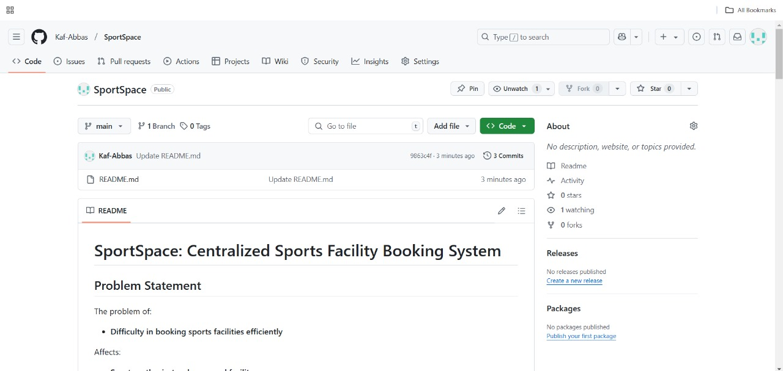

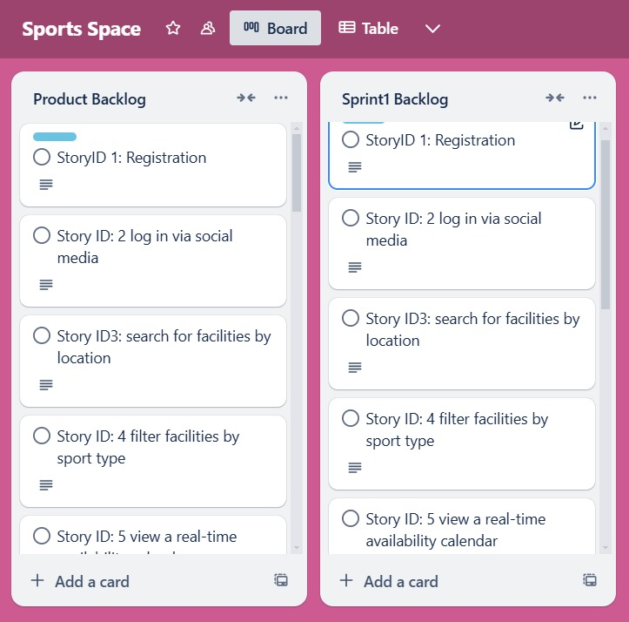

## 

## **TEAM AGREEMENT**

**Communication**:

* **Tools**: Slack for daily updates, Zoom for weekly meetings.
* **Response Times**: Slack within 2 hours, emails within 24 hours.  
  **Meetings**:
* Weekly Zoom calls (mandatory; notes shared via Google Docs).
* Daily 15-minute Slack stand-ups.  
  **Version Control**:
* GitHub with feature branches. Commit messages must describe changes (e.g., "Fix payment gateway error").  
  **Work Division**:
* Tasks assigned during sprint planning based on expertise.
* Pair programming for complex features.  
  **Contingency Planning**:
* Redistribute tasks if a member drops out.
* Escalate academic dishonesty to the instructor.